Class 5 GLMs and Graduation
Yubo Rasmussen and Alistair Wallis

Introduction
This document explores Gompertz’s law of mortality using different modeling approaches, including normal models, Poisson regression, and binomial models (GLMs), applied to CMI data.
Let us first load the data, ensuring that the files CMI_Deaths.csv and CMI_Exposures.csv are inside your working directory. You can use the R script CMI_read.r on Canvas which will read in the datasets and tidy them up.
source("CMI_read.r")

Normal Models
We begin by fitting a normal model, i.e. a linear regression model, to the logarithm of observed forces of mortality, after first assuming our observations of deaths for each age come from a Poisson model of mortality. Can you recall what this looks like mathematically?

Select Data for Year 2000, Ages 40-80
Your Task first is to select and store the number of deaths and exposure for ages 40-80 in 2000. Define a new variable “Obs” that adjusts for exposure and plot “Age” against “Obs”.
DTH <- Dth[ (40 <= Age) & (Age <= 80), Year == 2000]
EXP <- Exp[ (40 <= Age) & (Age <= 80), Year == 2000]
AGE <- 40:80
Obs <- log(DTH/EXP)
plot(AGE, Obs, xlab = "Age", ylab = "log(mortality)", main = "Gompertz Law: CMI Data, Ages 40-80, Year 2000")
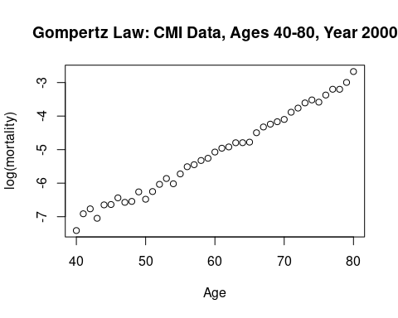
Q: The Gompertz law of mortality states that mortality rates increase exponentially with age. Why do we use Obs <- log(DTH/EXP)?

Fit Simple Normal Model
Let us proceed to fit a simple normal model:
$$log\left(\text{Obs}\right)=β_{0}+β_{1}\text{Age}+ε_{i}$$
Using lm, proceed to fit Obs ~ AGE. Add the line of best fit from your regression model to the plot above.
Gomp.fit <- lm(Obs ~ AGE)
# Alternatively as a GLM: Gomp.fit <- glm(Obs ~ AGE, family = gaussian)
names(Gomp.fit)
[1] "coefficients" "residuals" "effects" "rank"
[5] "fitted.values" "assign" "qr" "df.residual"
[9] "xlevels" "call" "terms" "model"
plot(AGE, Obs, xlab = "Age", ylab = "log(mortality)",
main = "Gompertz Law: CMI Data, Ages 40-80, Year 2000")
lines(AGE, Gomp.fit$fit, lwd = 2)
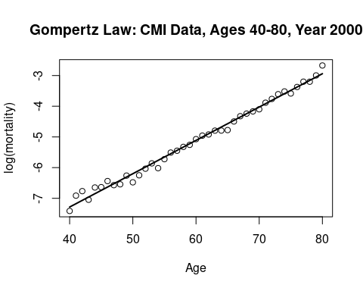
What are the coefficients of the fitted model?
Gomp.fit$coefficients
(Intercept) AGE
-11.6285913 0.1086161
How would you interpret this model and what is $ε_{i}$?

Fit Weighted Normal Model
A simple normal model assumes that all observations are equally important, whereas a weighted normal model says otherwise. The weighted model assigns weights to observations based on the number of deaths, where ages with more deaths have a higher effect on the regression line, and vice versa.
Now you will proceed to fit a weighted normal model, and plot it as before. Are there any differences in the results between the two models?
Gomp.fit.w <- lm(Obs ~ AGE, weights = DTH)
plot(AGE, Obs, xlab = "Age", ylab = "log(mortality)",
main = "Gompertz Law: CMI Data, Ages 40-80, Year 2000")
lines(AGE, Gomp.fit.w$fit, lwd = 2, lty = 2)
text(42, -3.5, "log(m) = -11.81 + 0.111 * Age, weighted", adj = 0, cex = 1.4)
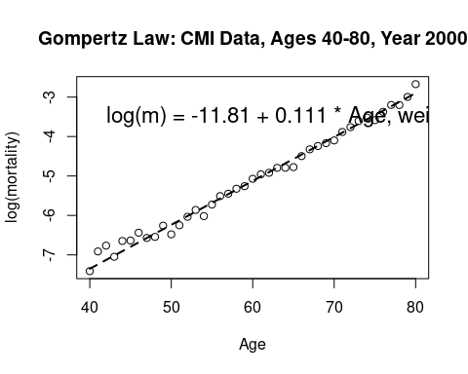

Residual Analysis
Residuals represent the difference between the actual observed values and the predicted values from our model. Examining residuals helps us understand the goodness of fit and whether the assumptions of the model hold.
- Compute the standard deviation of residuals: This is used to standardize the residuals.
- Compute the standardised residuals: These are defined as $z_{i}=\frac{y_{i}−{\hat{y}}_{i}}{σ}$, where $σ$ is the residual standard deviation. [Think about how this would be adjusted for the weighted linear model]
- Plot residuals: This helps identify potential outliers and checks if residuals are randomly distributed (which supports model validity).
First, let us consider the model without weights:
Sigma <- sqrt(sum(Gomp.fit$res^2)/Gomp.fit$df.res)
# Alternatively: Sigma <- summary(Gomp.fit)$sigma
Z.vals <- (Obs - Gomp.fit$fit)/Sigma
# Alternatively:
# Z.vals <- Gomp.fit$res/Sigma
# Z.vals <- resid(Gomp.fit, type = "pear")/Sigma
# Z.vals <- resid(Gomp.fit, type = "deviance")/Sigma
plot(AGE, Z.vals, ylab = "Standardized Residuals",
main = "Residuals in Gompertz Model: Normal Errors")
abline(h = 0, lty = 2, col = "red")
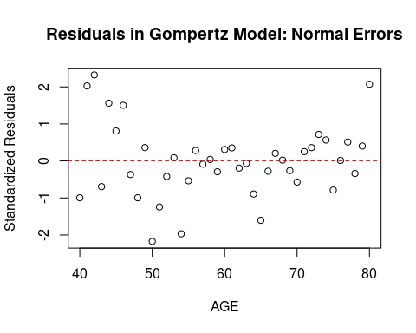
What are your Interpretations of the residuals?
- If the residuals are randomly scattered around zero, the model’s assumptions are likely valid, it doesn’t look like the normal assumption is valid here.
- Systematic patterns in the residual plot suggest potential model misspecifications, it seems like there is a quadratic pattern.
- Large residuals may indicate outliers or data issues, which is not an issue here.
More advanced topics:
For those also studying F79MB Statistical Models B, try to calculate the following:
Residual deviance:
sum((Obs - Gomp.fit$fit)^2)
[1] 0.6523911
# Alternatively:
# Gomp.fit_GLM <- glm(Obs ~ AGE, family = gaussian)
# R = resid(Gomp.fit_GLM, type = "deviance")
# sum(R^2)
# or simply:
# Gomp.fit_GLM$deviance
Null deviance:
ave_y = mean(Obs)
sum_of_squares = sum((Obs - ave_y)^2)
sum_of_squares
[1] 68.36974
# check: summary(Gomp.fit_GLM)$null
AIC:
n = length(Obs)
AIC_LM = sum((Obs - Gomp.fit$fit)^2)/Sigma^2 + 2*n*log(Sigma*sqrt(2*pi)) + 6
AIC_LM
[1] -47.36462
# Alternatively: summary(Gomp.fit_GLM)$aic
# Note slight discrepancy

Poisson Model
In this section, we model mortality rates using a Poisson Generalised Linear Model (GLM) with a log-link function. The Poisson model assumes that the number of deaths follows a Poisson distribution:
$$D_{x}∼\text{Poisson}\left(λ_{x}\right)$$
where the logarithm of the expected deaths is modeled as a linear function of age:
$$log\left(λ_{x}\right)=β_{0}+β_{1}x+log\left({\text{EXP}}_{x}\right)$$
Here, ${\text{EXP}}_{x}$ is the exposure (i.e., number of life-years at risk), included as an offset in the model.

Fit the Poisson GLM Model
Gomp.glm <- glm(DTH ~ offset(log(EXP)) + AGE, family = poisson)
summary(Gomp.glm)
Call:
glm(formula = DTH ~ offset(log(EXP)) + AGE, family = poisson)
Coefficients:
Estimate Std. Error z value Pr(>|z|)
(Intercept) -11.823753 0.072473 -163.15 <2e-16 ***
AGE 0.111544 0.001128 98.91 <2e-16 ***
---
Signif. codes: 0 '***' 0.001 '**' 0.01 '*' 0.05 '.' 0.1 ' ' 1
(Dispersion parameter for poisson family taken to be 1)
Null deviance: 9482.758 on 40 degrees of freedom
Residual deviance: 88.447 on 39 degrees of freedom
AIC: 379.76
Number of Fisher Scoring iterations: 4
- The offset(log(EXP)) ensures that the model adjusts for exposure.
- The estimated coefficients $β_{0}$ and $β_{1}$ determine the mortality curve.

Interpret the Coefficients
- The intercept ($β_{0}$) represents the log mortality rate at the baseline age.
- The slope ($β_{1}$) determines how mortality increases with age.
- A positive slope indicates that mortality increases exponentially over time, consistent with Gompertz’s Law.

Plot the results for visualisation
Visualise the observed mortality rates and compare them with model predictions.
plot(AGE, Obs, xlab = "Age", ylab = "log(mortality)",
main = "Gompertz Law: Poisson Model, CMI Data, Ages 40-80")
# Add the fitted Poisson regression line
lines(AGE, Gomp.glm$coef[1] + Gomp.glm$coef[2]*AGE, col = "green", lwd = 2)
lines(AGE, log(Gomp.glm$fit/EXP), col = "blue", lwd = 2)
# Add a legend for clarity
legend("topleft", legend = c("Poisson Model (Linear Predictor)",
"Poisson Model (Fitted Values)"),
col = c("green", "blue"), lty = c(1, 1), lwd = 2)
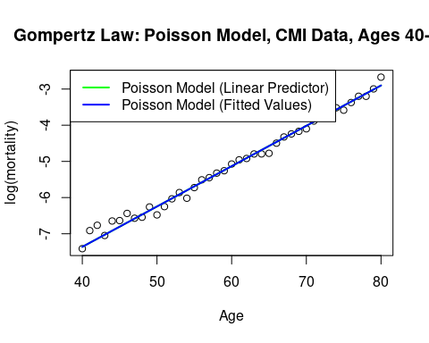

Alternative Visualisation: Comparing Poisson and Normal Model
Since we already fitted a normal model (OLS regression), it is useful to compare it with the Poisson model.
plot(AGE, Obs, xlab = "Age", ylab = "log(mortality)",
main = "Comparison: Normal vs Poisson Model")
lines(AGE, Gomp.fit$fit, col = "red", lwd = 2, lty = 2) # Normal Model
lines(AGE, log(Gomp.glm$fit/EXP), col = "blue", lwd = 2) # Poisson Model
legend("topleft", legend = c("Normal Model", "Poisson Model"),
col = c("red", "blue"), lty = c(2,1), lwd = 2)
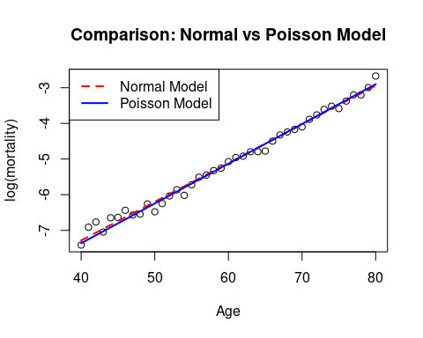

Residual Analysis for Poisson Model
Residuals help us assess model fit and detect possible misspecifications.

Plot the Pearson and Deviance Residuals
- Pearson residuals measure how far observed values deviate from expected values, standardized by variance.
- Deviance residuals quantify goodness of fit by comparing observed and fitted values.
plot(AGE, resid(Gomp.glm, type = "pear"), xlab = "Age",
ylab = "Residuals", main = "Residuals in Gompertz Model: Poisson")
points(AGE, resid(Gomp.glm, type = "deviance"), pch = 2, col = "red")
legend(50, 4, legend = c("Pearson Residuals", "Deviance Residuals"),
pch = c(1, 2), col = c("black", "red"))
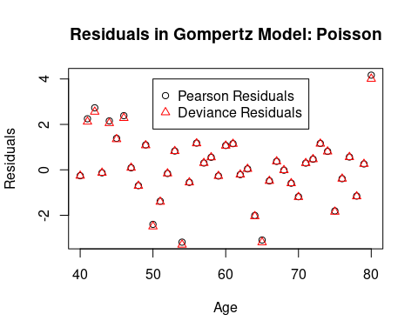
More advanced
Try to calculate the Pearson and deviance residuals yourself
# Pearson
(DTH - Gomp.glm$fit)/sqrt(Gomp.glm$fit)
40 41 42 43 44 45
-0.25911243 2.24734078 2.72930222 -0.13077710 2.15227686 1.38600486
46 47 48 49 50 51
2.38322939 0.09008763 -0.69600909 1.09584853 -2.39917512 -1.38040507
52 53 54 55 56 57
-0.15999045 0.82853296 -3.18120467 -0.55074158 1.17732434 0.29968100
58 59 60 61 62 63
0.55237381 -0.27068286 1.07099358 1.15250786 -0.21030651 0.04063406
64 65 66 67 68 69
-2.00769088 -3.08698810 -0.48546585 0.37162585 -0.01570188 -0.58788038
70 71 72 73 74 75
-1.18217398 0.29563174 0.46924671 1.16315696 0.81165625 -1.80795274
76 77 78 79 80
-0.38997347 0.56375968 -1.15366745 0.25835315 4.16590085
# deviance residuals
2*(DTH*(log(DTH)-Gomp.glm$lin)-DTH+Gomp.glm$fit)
40 41 42 43 44 45
6.827628e-02 4.485003e+00 6.527838e+00 1.721908e-02 4.219113e+00 1.813610e+00
46 47 48 49 50 51
5.198385e+00 8.088703e-03 4.964044e-01 1.161520e+00 6.201341e+00 1.978512e+00
52 53 54 55 56 57
2.569396e-02 6.748448e-01 1.085276e+01 3.068662e-01 1.354854e+00 8.930483e-02
58 59 60 61 62 63
3.020103e-01 7.364590e-02 1.124284e+00 1.300730e+00 4.439551e-02 1.649970e-03
64 65 66 67 68 69
4.175509e+00 1.017269e+01 2.383470e-01 1.369309e-01 2.466377e-04 3.502986e-01
70 71 72 73 74 75
1.436456e+00 8.682269e-02 2.179216e-01 1.319571e+00 6.474473e-01 3.406111e+00
76 77 78 79 80
1.533771e-01 3.140328e-01 1.365131e+00 6.639192e-02 1.603330e+01

Alternative Residual Analysis: Q-Q Plot
A Q-Q plot compares the residuals to a normal distribution to check for deviation from normality.
qqnorm(resid(Gomp.glm, type = "pear"), main = "Q-Q Plot: Poisson Residuals")
qqline(resid(Gomp.glm, type = "pear"), col = "red")
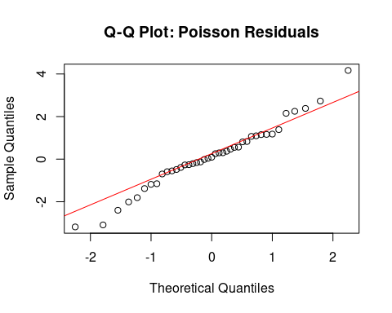

What are potential model refinements?
If residuals indicate poor fit:
1. Quadratic Model: Add an $AGE^{2}$ term to allow for curvature.
2. Binomial Model: If overdispersion is present, a binomial GLM may be more appropriate.
3. Spline Regression: A generalised additive model (GAM) could capture nonlinear trends.
More advanced topics:
For those also studying F79MB Statistical Models B, try to calculate the following:
Residual deviance:
Dev_Poi <- 2*(DTH*(log(DTH)-Gomp.glm$lin)-DTH+Gomp.glm$fit)
sum(Dev_Poi)
[1] 88.44693
# Alternatively:
# check: Gomp.glm$deviance
Null deviance:
K = sum(DTH)/sum(EXP)
null_dev_poi <- sum(2*(DTH*(log(DTH)-log(EXP*K))-DTH+EXP*K))
null_dev_poi
[1] 9482.758
# Alternatively, fit the null model:
# null_glm <-glm(DTH ~ offset(log(EXP)), family = poisson)
# null_dev_poi <- sum(2*(DTH*(log(DTH)-log(null_glm$fit))-DTH+null_glm$fit))
# check: summary(Gomp.glm)$null
AIC:
log_fact_pois = rep(0,41)
for (j in 1:41){
for (i in 1:DTH[j]){
log_fact_pois[j] = log_fact_pois[j]+log(i)
}
}
AIC_pois <- 4 - 2*sum(DTH*Gomp.glm$lin - Gomp.glm$fit - log_fact_pois)
AIC_pois
[1] 379.7609
# Check: summary(Gomp.glm)$aic

Binomial Model
Now, we move to the Binomial Generalised Linear Model (GLM) using a logit-link function. This model assumes that the number of deaths follows a binomial distribution:
$$D_{x}∼\text{Binomial}\left(E_{x},q_{x}\right)$$
and we are aiming to model
$${\tilde{q}}_{x}=\frac{D_{x}}{E_{x}}$$
where the logit transformation is applied to mortality probabilities:
$$log\left(\frac{q_{x}}{1−q_{x}}\right)=β_{0}+β_{1}x$$

Fit the Binomial Model
E.init <- EXP + DTH/2 # Initial exposure to risk
Q.x <- DTH / E.init # Mortality probability estimate
Logit <- function(x) log(x / (1 - x)) # Define logit function
Obs <- Logit(Q.x) # Transform mortality rates
# Fit the Binomial GLM
Gomp.bin <- glm(Q.x ~ AGE, weights = E.init, family = binomial)
summary(Gomp.bin)
Call:
glm(formula = Q.x ~ AGE, family = binomial, weights = E.init)
Coefficients:
Estimate Std. Error z value Pr(>|z|)
(Intercept) -11.858352 0.073177 -162.05 <2e-16 ***
AGE 0.112203 0.001141 98.34 <2e-16 ***
---
Signif. codes: 0 '***' 0.001 '**' 0.01 '*' 0.05 '.' 0.1 ' ' 1
(Dispersion parameter for binomial family taken to be 1)
Null deviance: 9483.109 on 40 degrees of freedom
Residual deviance: 90.804 on 39 degrees of freedom
AIC: 381.59
Number of Fisher Scoring iterations: 4

Visualise the Binomial Model
plot(AGE, Obs, xlab = "Age", ylab = "logit(mortality)",
main = "Gompertz Law: Binomial Model, Logit Link")
# Add the fitted Binomial regression line
lines(AGE, Gomp.bin$coef[1] + Gomp.bin$coef[2] * AGE, col = "red", lwd = 2)
lines(AGE, Logit(Gomp.bin$fit), col = "blue", lwd = 2)
legend("topleft", legend = c("Linear Predictor", "Fitted Values"),
col = c("red", "blue"), lty = c(1, 1), lwd = 2)
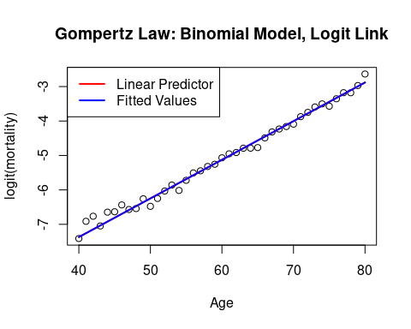

Perform Residual Analysis for Binomial Model
plot(AGE, resid(Gomp.bin, type = "pear"), xlab = "Age",
ylab = "Residuals", main = "Residuals in Gompertz Model: Binomial")
points(AGE, resid(Gomp.bin, type = "deviance"), pch = 2, col = "red")
legend(50, 4, legend = c("Pearson Residuals", "Deviance Residuals"),
pch = c(1, 2), col = c("black", "red"))
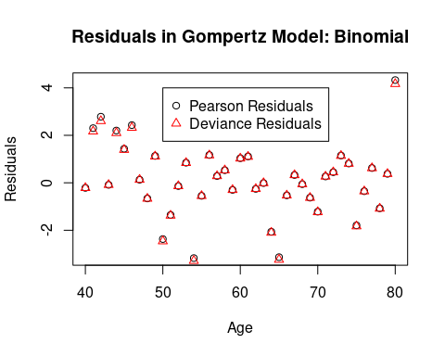

Interpret the Residuals
- If residuals are randomly distributed, the model is a good fit.
- Patterns in residuals suggest a need for a more flexible model (e.g., a quadratic term or splines).
- Large residuals may indicate outliers or data misfits.
More advanced topics:
Try to calculate the Pearson and deviance residuals yourself:
# Pearson
(DTH - E.init*Gomp.bin$fit)/sqrt(E.init*Gomp.bin$fit)
40 41 42 43 44 45
-0.21540709 2.29976266 2.78216971 -0.08780345 2.20025845 1.43064467
46 47 48 49 50 51
2.42763594 0.12886911 -0.66039130 1.13021584 -2.36998404 -1.35409160
52 53 54 55 56 57
-0.13810709 0.84413184 -3.16910543 -0.54904209 1.16793252 0.28407888
58 59 60 61 62 63
0.52849939 -0.29846853 1.03232701 1.10648682 -0.25671699 -0.01278745
64 65 66 67 68 69
-2.05338880 -3.11881601 -0.52655982 0.32496992 -0.05821823 -0.62261203
70 71 72 73 74 75
-1.20637898 0.26249972 0.44150927 1.13547736 0.80042885 -1.76695838
76 77 78 79 80
-0.34976069 0.60931075 -1.05157767 0.36717740 4.20967492
# deviance residuals
2*(DTH*(Logit(Q.x)-Gomp.bin$lin)+E.init*(log(1-Q.x)-log(1-Gomp.bin$fit)))
40 41 42 43 44 45
4.708273e-02 4.686832e+00 6.771130e+00 7.751481e-03 4.404583e+00 1.930905e+00
46 47 48 49 50 51
5.391974e+00 1.655092e-02 4.470206e-01 1.236413e+00 6.056970e+00 1.906432e+00
52 53 54 55 56 57
1.918213e-02 7.021973e-01 1.079803e+01 3.059859e-01 1.338741e+00 8.061393e-02
58 59 60 61 62 63
2.779162e-01 9.006138e-02 1.051661e+00 1.208074e+00 6.669666e-02 1.649148e-04
64 65 66 67 68 69
4.410406e+00 1.049144e+01 2.839002e-01 1.061956e-01 3.443274e-03 3.995419e-01
70 71 72 73 74 75
1.523242e+00 6.990951e-02 1.974899e-01 1.291220e+00 6.481264e-01 3.350104e+00
76 77 78 79 80
1.276423e-01 3.813324e-01 1.181147e+00 1.405549e-01 1.735549e+01
For those also studying F79MB Statistical Models B, try to calculate the following:
Residual deviance:
Dev_bin <- 2*(DTH*(Logit(Q.x)-Gomp.bin$lin)+E.init*(log(1-Q.x)-log(1-Gomp.bin$fit)))
sum(Dev_bin)
[1] 90.80416
# Alternatively:
# check: Gomp.bin$deviance
Null deviance:
qx_full <- sum(DTH)/sum(E.init)
null_dev_bin <- sum(2*(DTH*(Logit(Q.x)-Logit(qx_full))+E.init*(log(1-Q.x)-log(1-qx_full))))
null_dev_bin
[1] 9483.109
# check: summary(Gomp.bin)$null
AIC:
log_prod_bin = rep(0,41)
for (j in 1:41){
for (i in 1:DTH[j]){
log_prod_bin[j] = log_prod_bin[j]+log((E.init[j] - i + 1)/i)
}
}
AIC_bin <- 4 - 2 * sum(DTH*Gomp.bin$lin + E.init*log(1-Gomp.bin$fit)+log_prod_bin)
AIC_bin
[1] 381.5928
# Check: summary(Gomp.bin)$aic

Gompertz Models Over Time
We now extend the Gompertz model to analyze how mortality changes over time for a given age.
DTH <- Dth[Age == 65, ]
EXP <- Exp[Age == 65, ]
Obs <- log(DTH / EXP)
plot(Year, Obs, xlab = "Year", ylab = "log(mortality)",
main = "Gompertz Style Models Over Time: Age 65")
Gomp.yr <- glm(DTH ~ offset(log(EXP)) + Year, family = poisson)
lines(Year, log(Gomp.yr$fit / EXP), lwd = 2, col = "blue")
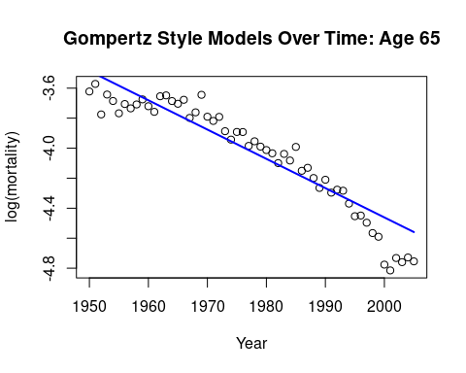

Quadratic Model for Time Trends
Year2 <- (Year - mean(Year))^2
Gomp.yr.2 <- glm(DTH ~ offset(log(EXP)) + Year + Year2, family = poisson)
plot(Year, Obs, xlab = "Year", ylab = "log(mortality)",
main = "Gompertz Style Models Over Time: Age 65")
lines(Year, log(Gomp.yr$fit / EXP), lwd = 2, col = "blue")
lines(Year, log(Gomp.yr.2$fit / EXP), lwd = 2, lty = 2, col = "red")
legend("bottomleft", legend = c("Linear Model", "Quadratic Model"),
col = c("blue", "red"), lty = c(1, 2), lwd = 2)
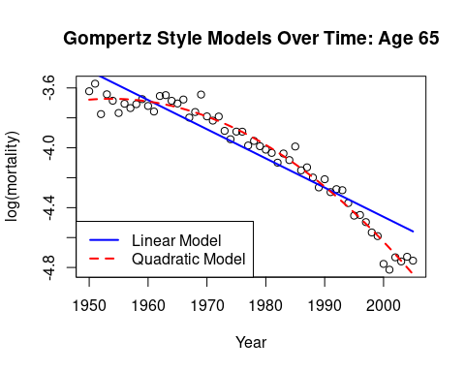

Residual Analysis for Time Trends
plot(Year, resid(Gomp.yr, type = "pear"), xlab = "Year",
ylab = "Residuals", main = "Residuals for Time-Based Model")
points(Year, resid(Gomp.yr.2, type = "pear"), pch = 2, col = "red")
legend("topright", legend = c("Linear Model Residuals", "Quadratic Model Residuals"),
pch = c(1, 2), col = c("black", "red"))
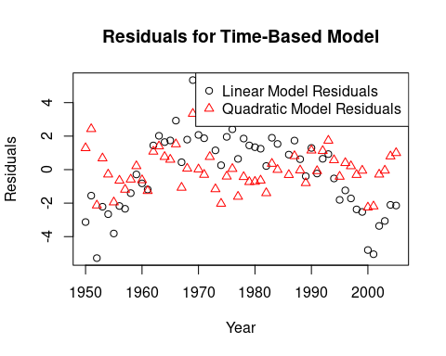

Conclusion
- The Poisson model works well but may suffer from overdispersion.
- The Binomial model provides an alternative framework based on survival probabilities.
- Time-based models suggest that mortality rates change over time and may require nonlinear adjustments.

